**Equipment and Supplies** (needed to prepare vent sharing between TWO (2) patients)

Specific equipment required may vary depending on supplies and equipment availability

1. One (1) ventilator (Master)
2. Two (2) sets up patient tubing (inspiratory = blue, expiratory = white)
3. Four (4) short circuit tubings
   1. Ideally two (2) pairs of distinctly different tubing colours (two (2) clear tubings and two (2) blue tubings)
4. Five (5) t-piece connectors (often used in spontaneous breathing trials)
5. Six (6) 22 mm to 22 mm connectors
6. Four (4) 15 mm to 15 mm connectors
7. Four (4) y-connectors (normally used for connection of patient endotracheal tube to ventilator)
8. Eight (8) one-way valves (to be connected in-line)
9. One (1) 1.5 – 2 L container with threaded flat top lid
10. One (1) 3D printer connection system
11. Two (2) 1 litre anesthesia breathing bags(used to ventilate patients in circle system ventilators)
12. Two (2) antimicrobial / heat and moisture exchangers (HMEs)
13. Two (2) manometers
14. Two (2) fresh gas flow lines
15. Two (2) adjustable PEEP valves (used in BMV circuits)
16. Two (2) Intersurgical™ APL valves (0-60 cm H2O)

Note: Combined HME + antimicrobial filters are recommended if available. If unavailable, then one could use separate antimicrobial and HME filters. The filter must be placed between the patient Y and the ETT tube in order to filter the gas that is both inspired to and expired from the patient.

**Images of required equipment**

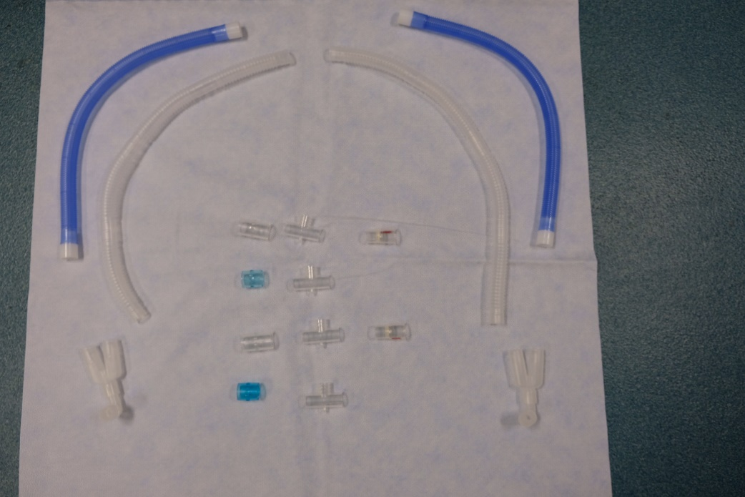

Y-connector   
with (optional) elbow connector

One-way valves

22 mm to 22 mm  
connectors

T-Pieces

Short Circuit Tubing

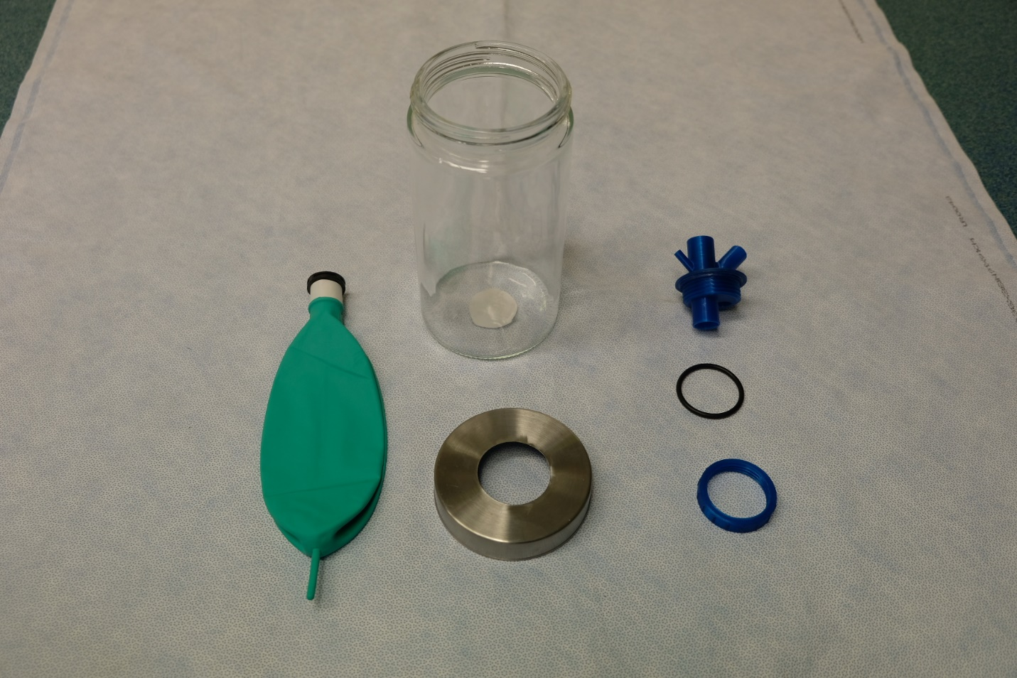

3D connection system and O ring

1.5 L container  
with threaded lid

Breathing

Bag

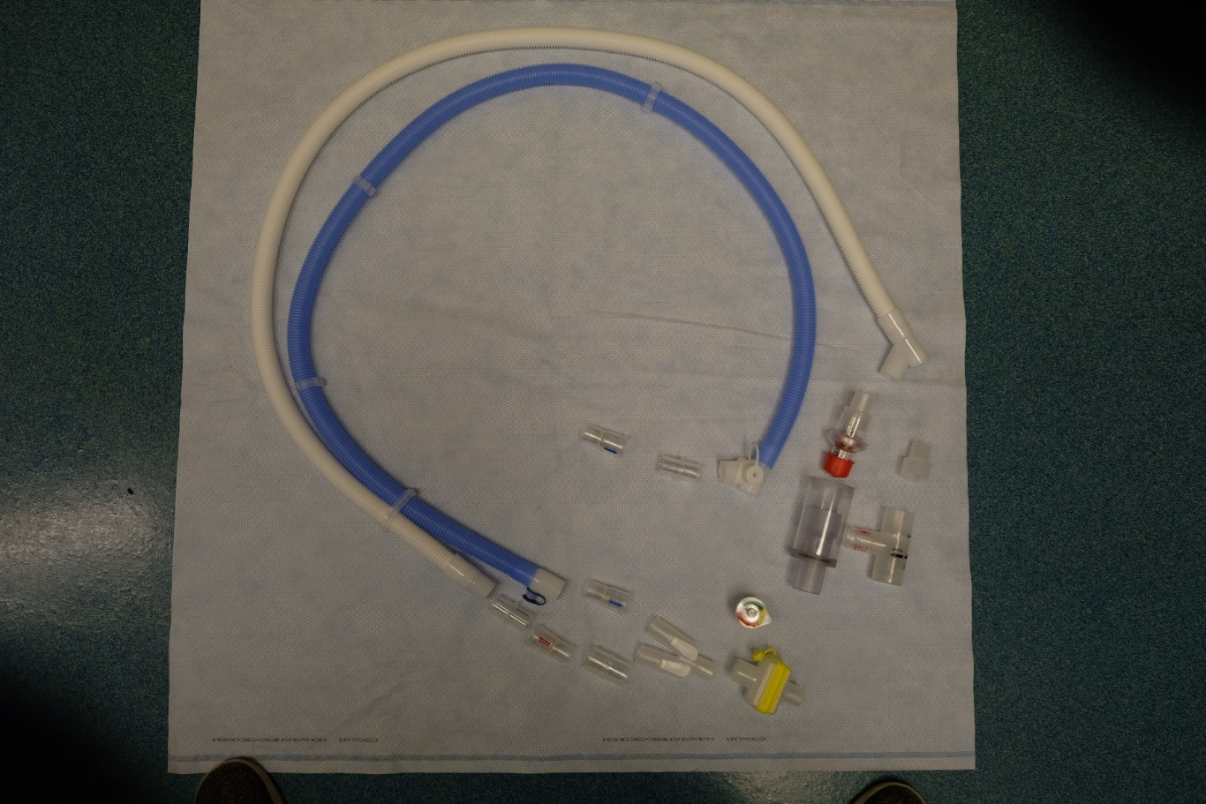

PEEP valve   
with connector

(2 options)

Manometer

HME +   
Antimicrobial  
filter

Patient Tubing



**Cerberus System Schematic**

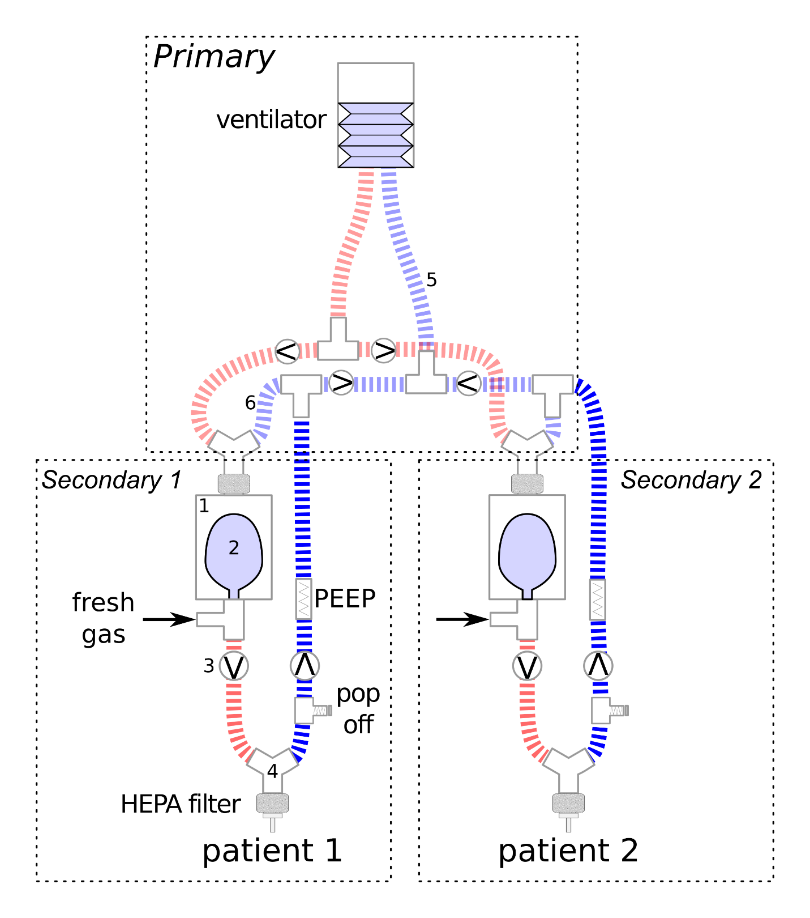

**Setting up the ventilator for two-patient ventilation**

|  |  |
| --- | --- |
| **Creation of the “Driving Circuits”** | |
| Step 1: | Connect 22 mm to 22 mm connector (blue) to bottom of one (1) t-piece |
|  | |
| Step 2: | Connect short blue tubing to each open end of t-piece. This becomes the common inspiratory limb split of the ventilator (Master). |
|  | |
| Step 3: | Connect the inspiratory limb t-piece (Step 2) to the common inspiratory port of the ventilator (Master) using the 22 mm to 22 mm connector previously attached (step 1) to the bottom of the t-piece. |
|  | |
| Step 4: | Connect 22 mm to 22 mm connectors to all ends of a t-piece. Use a blue 22 mm to 22 mm connector for the bottom limb of the t-piece. This becomes the common expiratory limb split of the ventilator (Master). |
| A picture containing sitting, small, suitcase, cat  Description automatically generatedA picture containing bag, bottle  Description automatically generated  → | |
| Step 5: | Connect t-tubes to each open end of the t-piece using the clear 22 mm to 22 mm connectors that were attached in step 4 |
| A picture containing indoor, sitting, small, bottle  Description automatically generated  A picture containing indoor, sitting, suitcase, luggage  Description automatically generated  ↓ Attach a two-limbed driving circuit (short blue and short clear tubings) that are y-connected to the ETT connector of the suction cannister. One driving circuit per cannister. Note: elbows are optionally placed between Y-connector and suction cannister ETT connector. | |
| Step 6: | Connect short clear tubing to the open ends of the inter-connected t-piece setup created in step 5. |
|  | |
| Step 7: | Connect one-way valves (flow direction = towards t-pieces; indicated by red arrow) in the remaining open bottoms of the t-pieces constructed in Steps 5-6. |
|  | |
| Step 8: | Connect final expiratory limb tree to the expiratory port of the ventilator (Master) using the 22 mm to 22 mm connector (blue) placed in step 4. |
|  | |
| Step 9: | Connect one (1) common inspiratory (short blue tubing) limb and one (1) common expiratory (short clear tubing) limb to two (2) ports of a y-connector. This creates a driving circuit for one patient. |
|  | |
| Step 10: | Connect the remaining common inspiratory (short blue tubing) limb and common expiratory (short clear tubing) limbs of the driving circuit to two (2) ports of a y-connector. This creates the second driving circuit. |
|  | |
| **Construction of “Bag in a bottle”** | |
| Step 11: | Cut hole of appropriate size into threaded lid (indicated by black shading)   * Our custom design uses a hole of diameter = 50 mm |
| A picture containing standing  Description automatically generatedA picture containing small  Description automatically generated  → | |
| Step 12: | Create 3D connection system with two primary communicating ports that will be exterior to the cannister and one port that will sit inside the sealed container.   * Smaller primary exterior port has an outer diameter = 15 mm (fits standard ETT elbow connector). * Larger primary exterior port has an inner diameter = 22 mm. This port is continuous with the interior port which has an outside diameter 21 mm.   + This larger primary exterior port requires a secondary inlet with an outside diameter = 6.5 mm   **See end of instructions for engineering specifications** |
|  | |
| Step 13: | Attach 3D connection system to lid using the 50 mm hole created in Step 11   * O ring sits between threaded washer and internal surface of lid. |
| A picture containing man  Description automatically generated  ↓ Attach a two-limbed driving circuit (short blue and short clear tubings) that are y-connected to the ETT connector of the suction cannister. One driving circuit per cannister. Note: elbows are optionally placed between Y-connector and suction cannister ETT connector.  A picture containing ware, sitting, small, table  Description automatically generatedA picture containing man  Description automatically generated | |
| Step 14: | Connect 1 L breathing bag to the port located on the internal side of the lid |
|  | |
| Step 15: | Place breathing bag inside bottle and close lid   * In order to increase seal of bottle, one can add plumber’s tape/self-fusing tape to the threads located on the glass bottle |
| A picture containing indoor, sitting, small, green  Description automatically generated    → | |
| Step 16: | Circumferentially seal the 3D printed connection system to the exterior surface of the lid.   * Any sealant can be used. We have used cyanoacrylate (Krazy Glue™/Gorilla Glue™) |
| → | |
| Step 17: | Circumferentially tape the smaller primary exterior port   * Use synthetic material such as electrical tape * This tape provides a smooth surface to facilitate a tight seal at this component. The 3D material is roughened and will leak otherwise. |
|  | |
| **Creation of “Individual” patient circuits** | |
| Step 18: | Connect one-way valve (direction of flow = away from cannister; indicated by blue arrow) to the larger primary port of completed “bag-in-a-bottle” |
| A picture containing sink, mirror, blue  Description automatically generatedA picture containing small, laying, sink, white  Description automatically generated  → | |
| Step 19: | Connect the other end of one-way valve to the proximal inspiratory limb (blue tubing) of the patient tubing using a 15mm to 15 mm connector. |
| A picture containing blue, laying  Description automatically generatedA picture containing indoor, white  Description automatically generated  → | |
| Step 20: | Connect a one-way valve (direction of flow = towards patient; indicated by blue arrow) to the distal end of the of the inspiratory limb (blue tubing).  → |
|  | |
| Step 21: | Connect the distal end of the inspiratory limb with one-way valve in place to one (1) port of a y- connector. |
|  | |
| Step 22: | Connect a one-way valve (direction of flow = away from patient; indicated by red arrow) to the distal end of the expiratory limb (white tubing) of the patient circuit using a 15 mm to 15 mm connector. |
| ↓ Attach a two-limbed driving circuit (short blue and short clear tubings) that are y-connected to the ETT connector of the suction cannister. One driving circuit per cannister. Note: elbows are optionally placed between Y-connector and suction cannister ETT connector.  A picture containing indoor, small, sink, white  Description automatically generated | |
| Step 23: | Connect the distal end of the expiratory limb (white tubing) with one-way valve in place to the other port of the y-connector using a 22 mm to 22 mm connector. |
| ↓ Attach a two-limbed driving circuit (short blue and short clear tubings) that are y-connected to the ETT connector of the suction cannister. One driving circuit per cannister. Note: elbows are optionally placed between Y-connector and suction cannister ETT connector.  A picture containing small, white, plastic, light  Description automatically generated | |
| Step 24: | place HME filter on distal port of y-connector immediately proximal to patient endotracheal tube. |
|  | |
| Step 25: | Install manometer into the gas sampling port of the HME filter   * Optionally, pressure tubing can be placed can be used to connect the manometer to the gas sampling port allowing one to extend the placement of the manometer |
|  | |
| Step 26: | Connect the proximal end of the expiratory limb of patient circuit to one of the one-way valves (Step 7) found on the common expiratory tree. |
|  | |
| Step 27: | **Repeat steps 11-26 for the other secondary patient circuit.** |
| Step 28: | Attach a two-limbed driving circuit (short blue and short clear tubings) that is y-connected to the ETT connector of the suction cannister. One driving circuit per cannister. |
|  | |
| Step 29: | Connect fresh gas flow to the sampling port of the gas sample tee adapter.   * Independent fresh gas flow is required for each patient circuit |
|  | |

|  |  |
| --- | --- |
| **How to add independent PEEP to a patient circuit** | |
| PEEP insertion: | Insert the PEEP valve between the one-way valve located at the proximal end of the patient circuit and the common expiratory tree.   * PEEP valves with directed vented gas must be used in order to vent any escaping flow back to the common expiratory tree.   A minimum PEEP valve of 5 cm H2O required in each secondary circuit expiratory limb |
| A picture containing indoor, lying, laying, bag  Description automatically generated  ↓ Attach a two-limbed driving circuit (short blue and short clear tubings) that are y-connected to the ETT connector of the suction cannister. One driving circuit per cannister. Note: elbows are optionally placed between Y-connector and suction cannister ETT connector.  A picture containing indoor, table, sitting, computer  Description automatically generated | |

NOTE: the custom PEEP valve adapter must be used as all flow exhausted by the PEEP valve must be recaptured by the ventilator in order to satisfy the ventilator ‘s volume detection . **See end of document for engineering specifications for custom design**

* If custom PEEP design is not possible one must used older PEEP valves with directed outflow (see alternate instructions for image) given back to the common expiratory port of the driving ventilator

|  |  |
| --- | --- |
| **How to add pop-off valve to each secondary circuit**  *Pop-off valve must be placed into the expiratory limb of each secondary circuit* | |
| Step 1: | Connect adjustable APL valve set to 45 cm H2O to the bottom limb of T-piece |
|  | |
| Step 2: | Remove the proximal 15 mm to 15 mm connector between the one-way valve and the expiratory limb |
| A close up of a device  Description automatically generated  →  ↓ Attach a two-limbed driving circuit (short blue and short clear tubings) that are y-connected to the ETT connector of the suction cannister. One driving circuit per cannister. Note: elbows are optionally placed between Y-connector and suction cannister ETT connector.  A picture containing bag  Description automatically generated | |
| Step 3: | Insert t-piece with APL valve attached into the expiratory limb between one-way valve and the expiratory limb |
|  | |

**Cerberus System – Physical Circuit**

* Connect common Inspiratory Limb into inspiratory port of driving ventilator
* Connect common expiratory limb tree into expiratory port of driving ventilator

Connection to driving ventilator expiratory port

Connection to driving ventilator inspiratory port

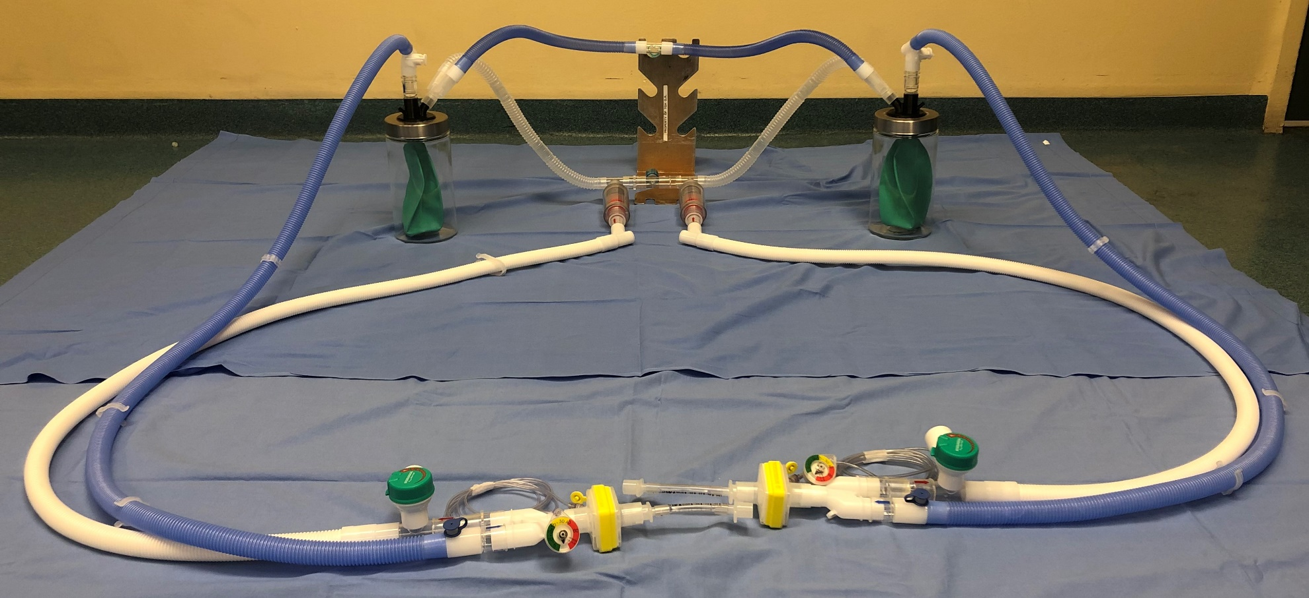

**Engineering Schematic of 3D printed connection system**









O – Ring = food grade Buna-n 1/8 ‘’ width   
(dash number 218)